Linux Basics Documentation

1. Install VirtualBox (Vagrant) on your laptop, spin up centos 7, and Ubuntu 18.04 Machine.   
   centos /7 and ubuntu/bionic64 are the Vagrant boxes that you need to download.
2. Find OS version, kernel version, uptime, memory, cores, and swap details of Linux machine.

OS and Kernel Version:

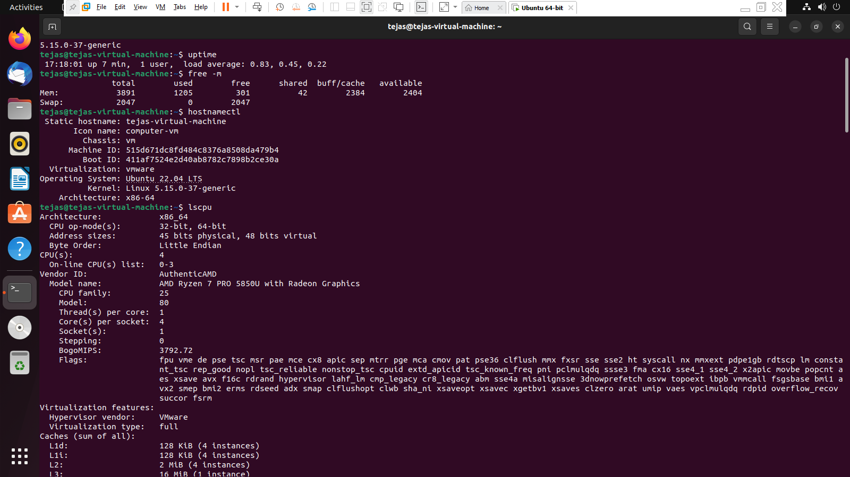

Uptime:

Memory:



Number of cores:

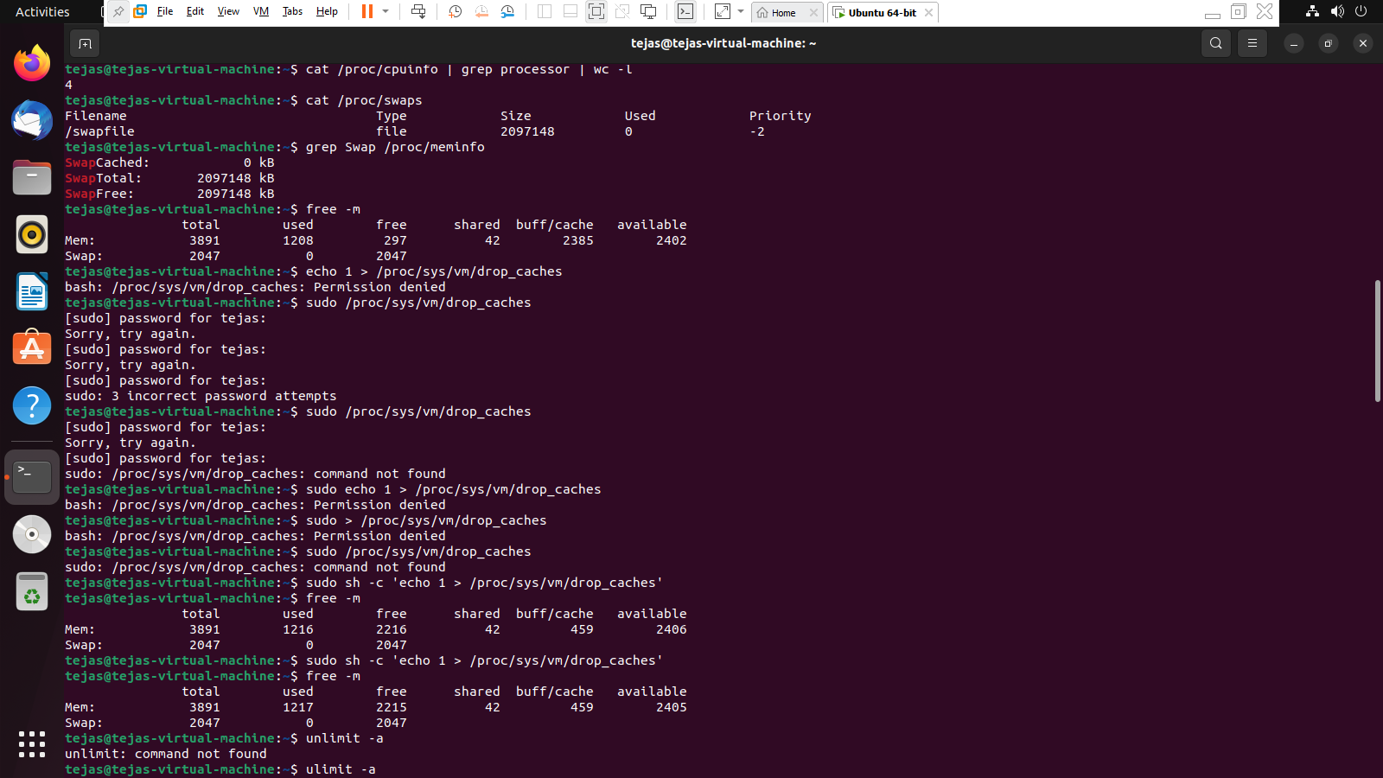

Swap Details:



a. Be ready to explain what is free & available memory.

b. Release all cache memory & how do you manage the same in a prod env.



c. Increase the ulimit for the current user to 1028.

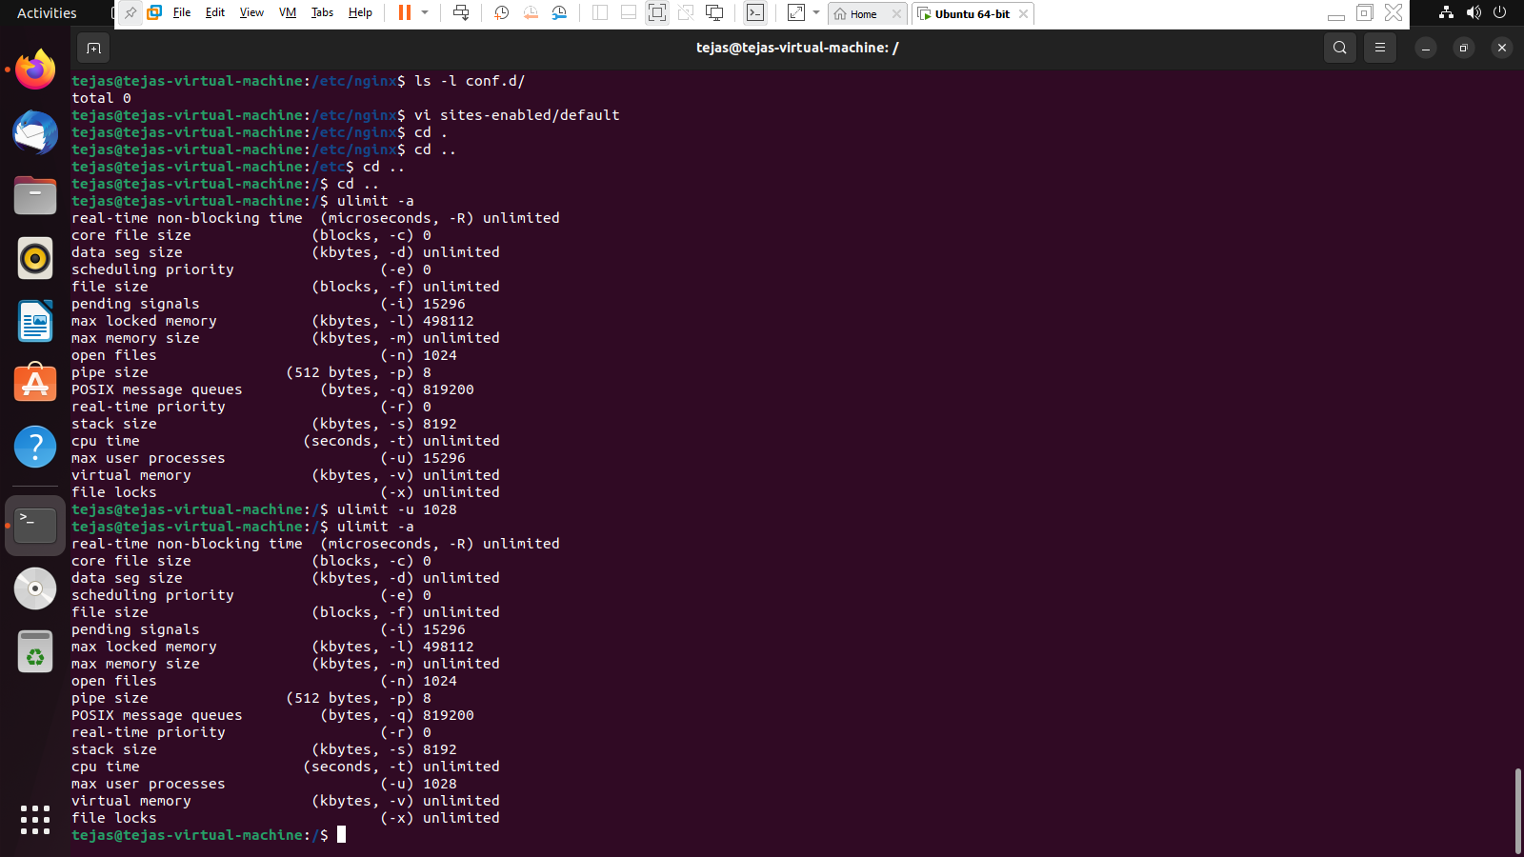

d. Change the timezone to IST

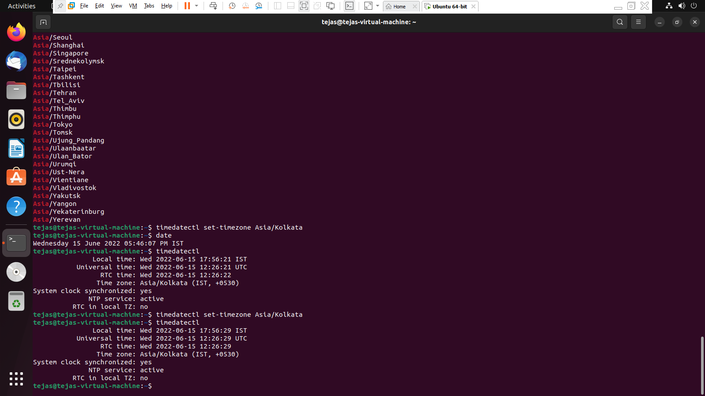

1. Install nginx

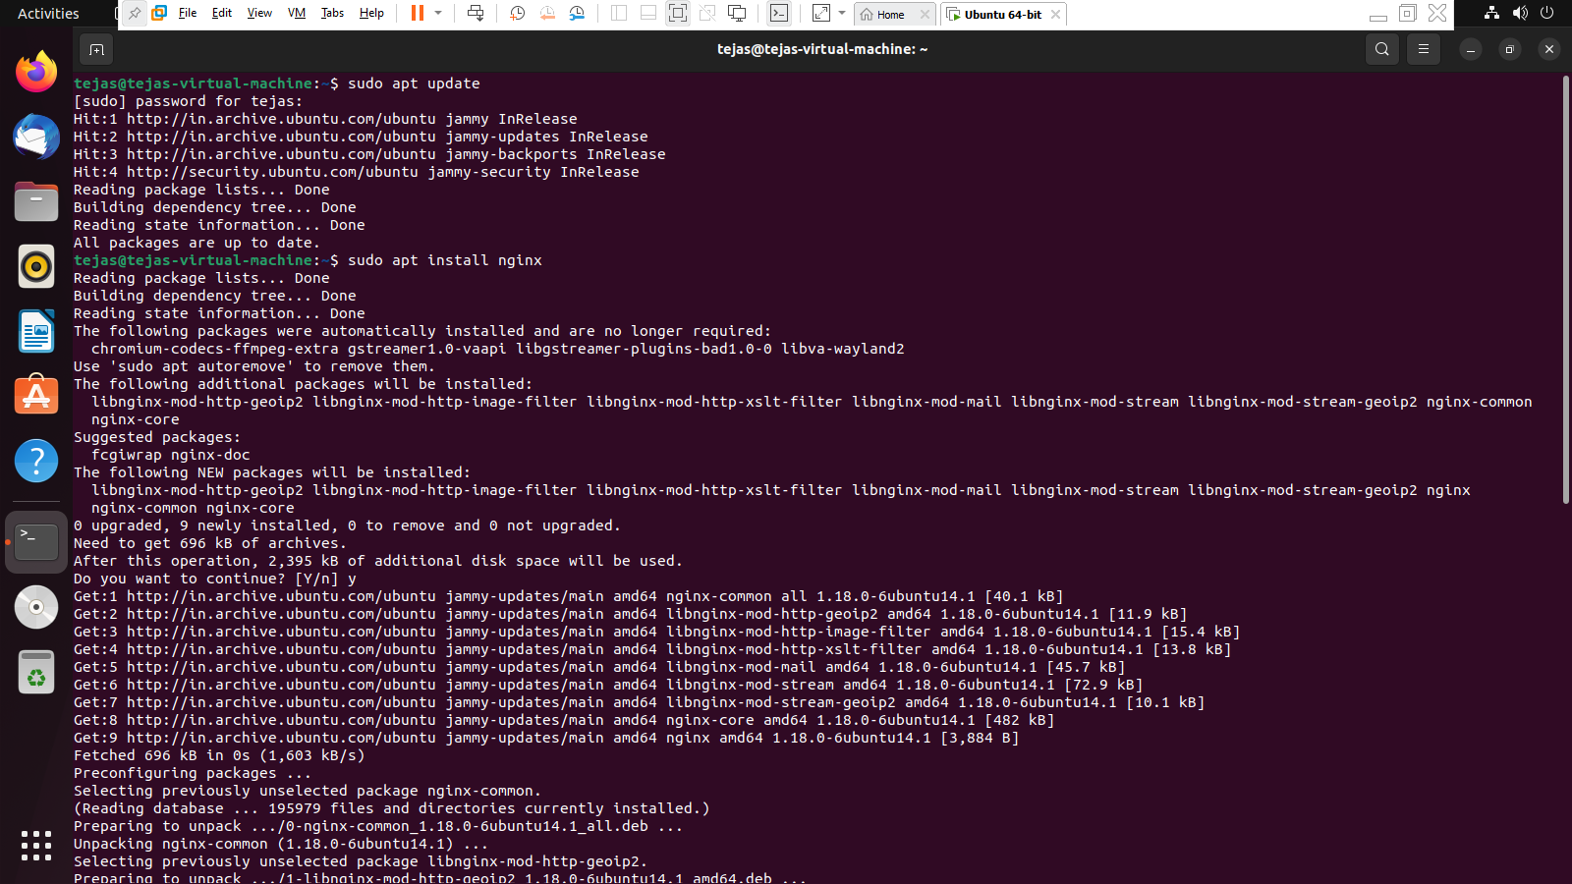

1. Configure the web server. Change the default location

b. Route all the requests to port 8080.

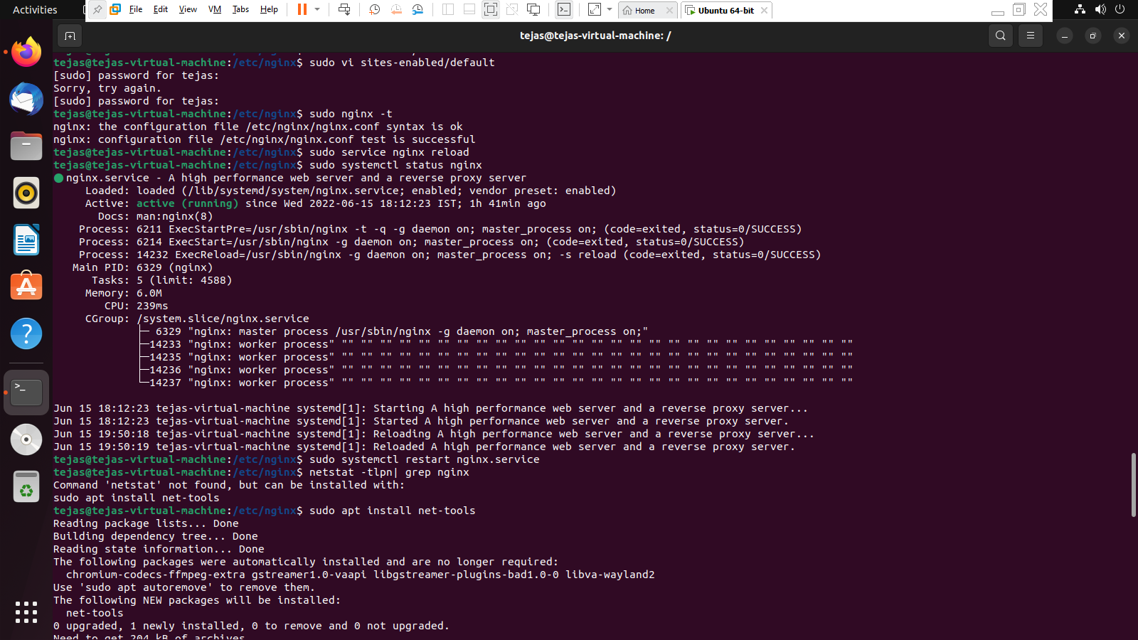

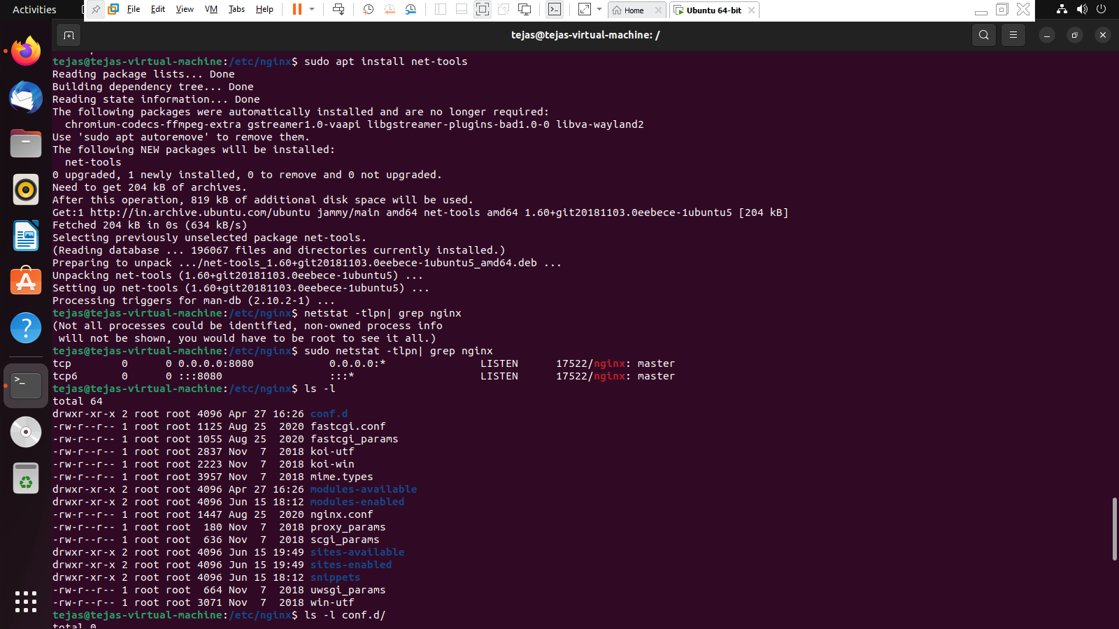

c. Configure the web server which shows files/directories and make them downloadable from the web page.

1. Create a job in crontab to create zip of system logs every last day of the month and keep

only the last 30 days’ logs.

1. Date and Calendar should print whenever I open the terminal.

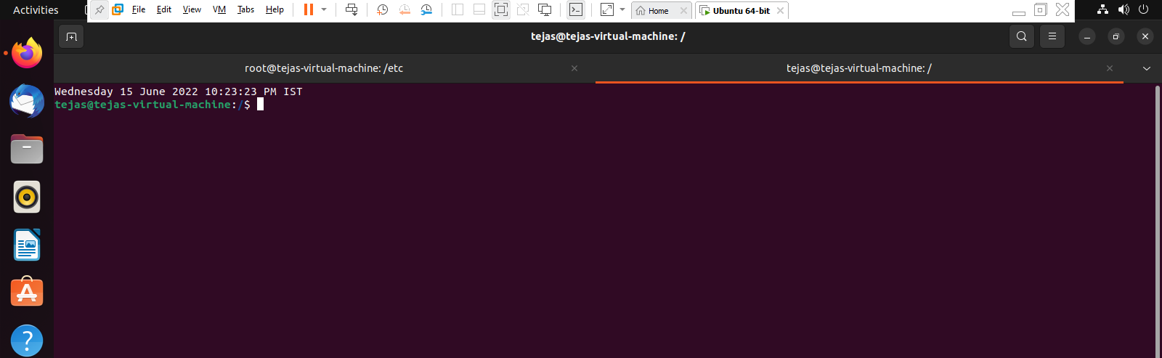

1. Create a User, and give it sudo privileges. But remove the power of rm.

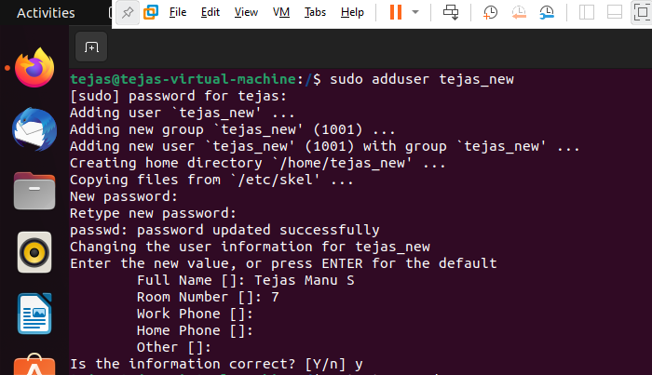

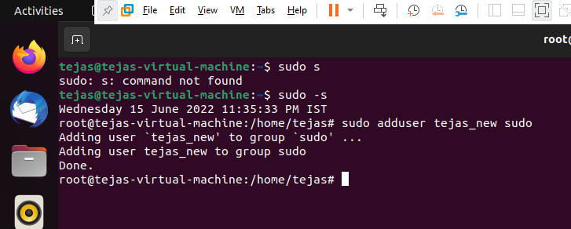

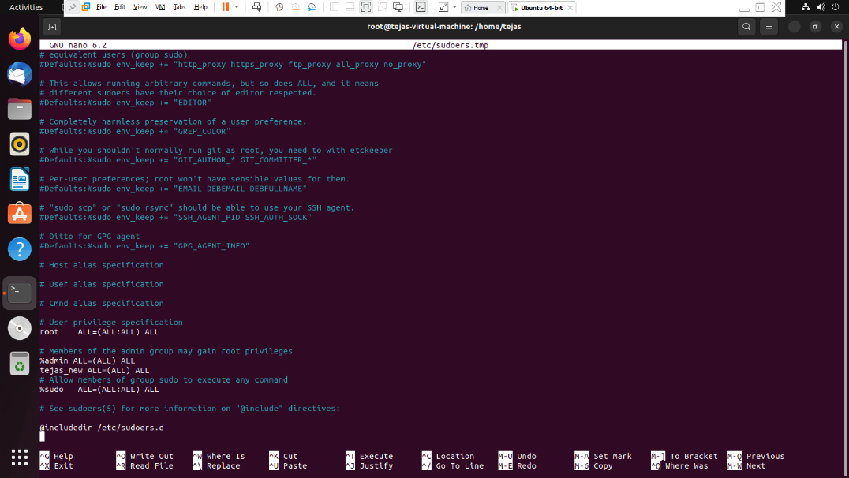

1. Change the default port number for RDP to 8339 and document on the same.

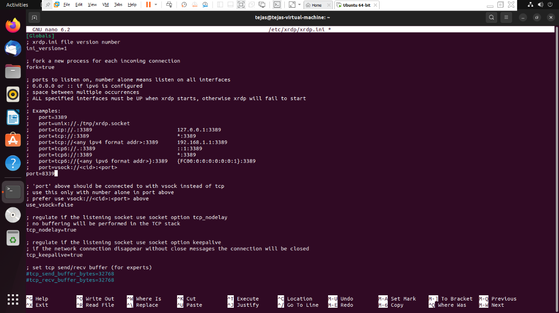

1. Create a script to take regular backup of the database(MySql & Postgres), say every day at 11PM.
2. Create a file that contains memory usage and the number of cpu in linux using the sed comma

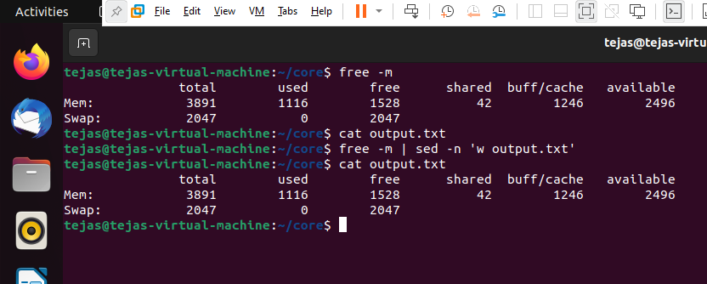

1. Find a file with all command line history and Delete the Complete Command line History.

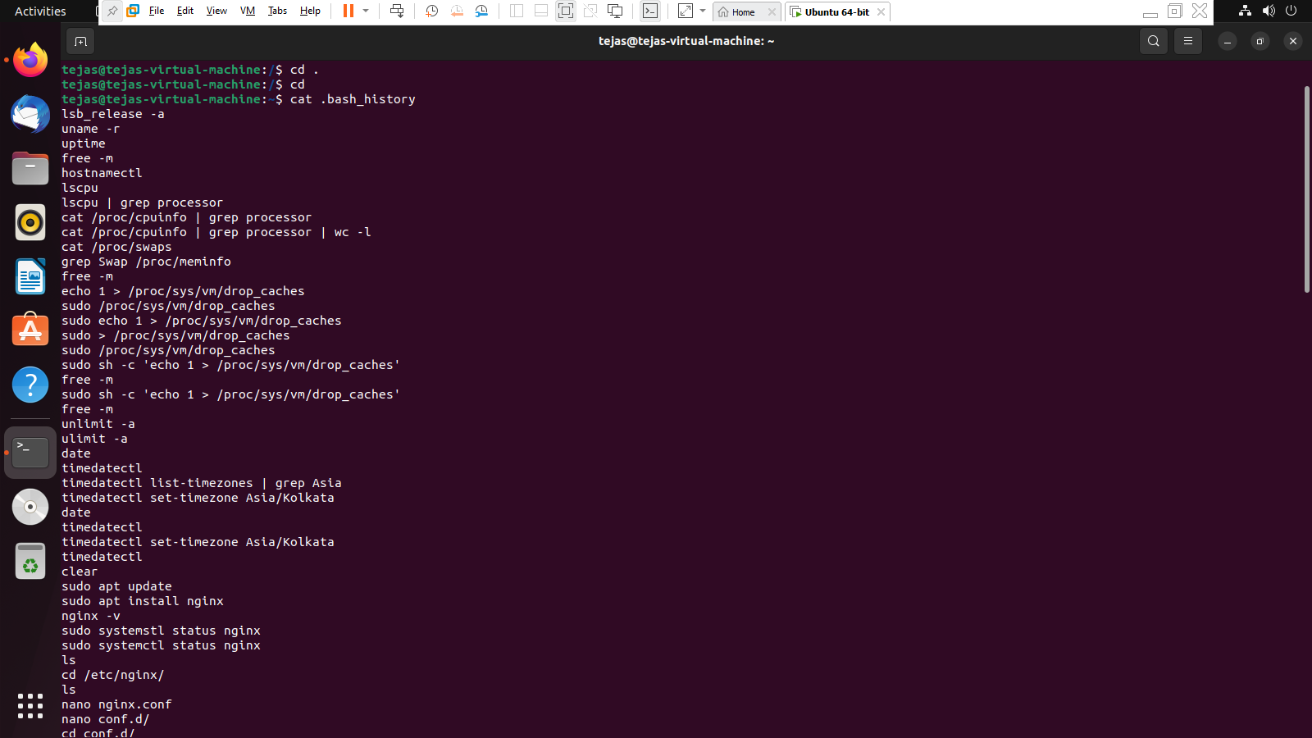

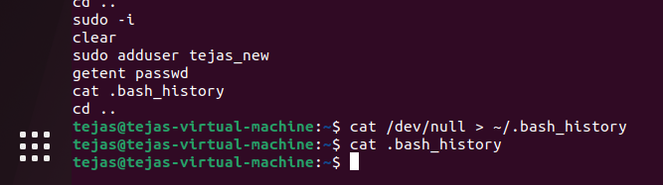

1. Detecting which process has the highest priority in the system. Now find out what its purpose is.

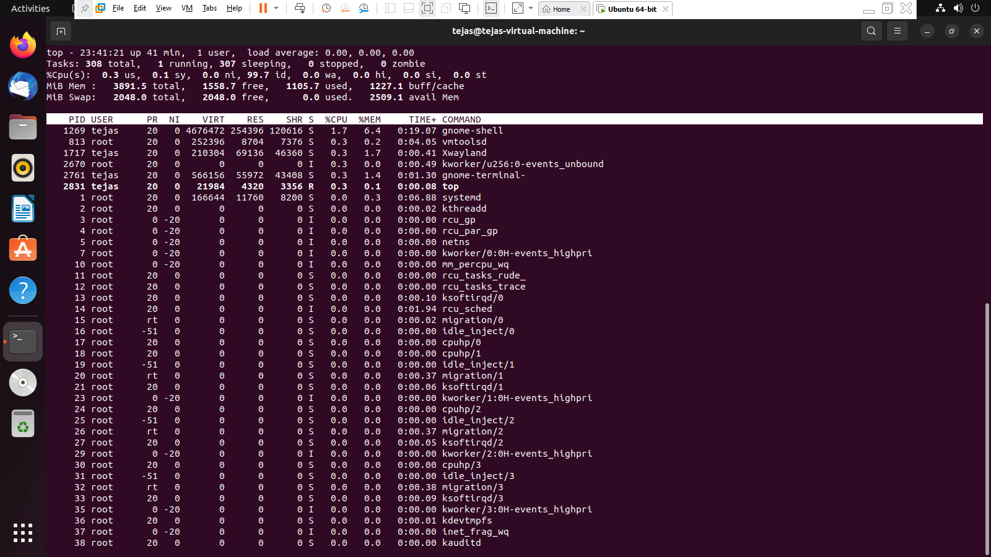

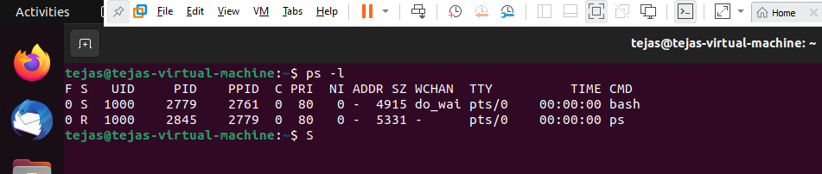

1. Perform the below tasks on the firewall using iptables:
2. Block outgoing connections on port 80

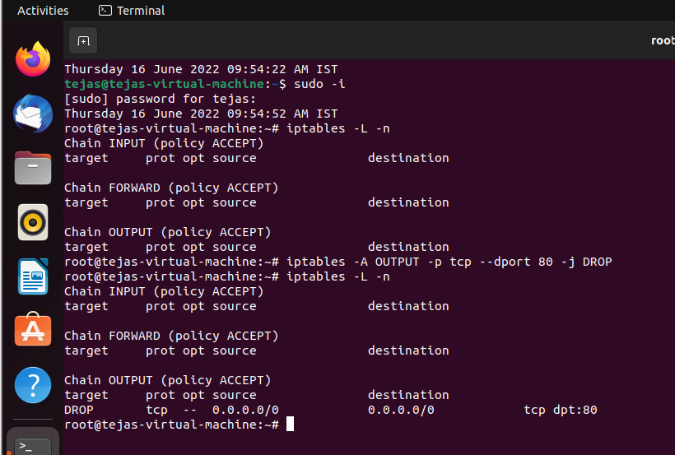

1. Allow incoming connections on port 3306

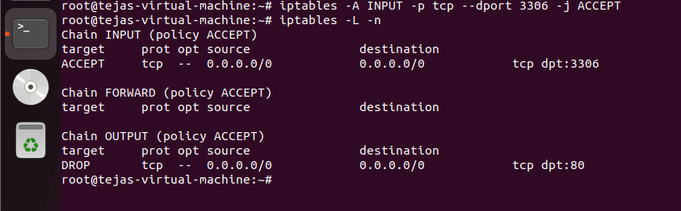

1. Allow both incoming and connections on port 80, 443 and 22

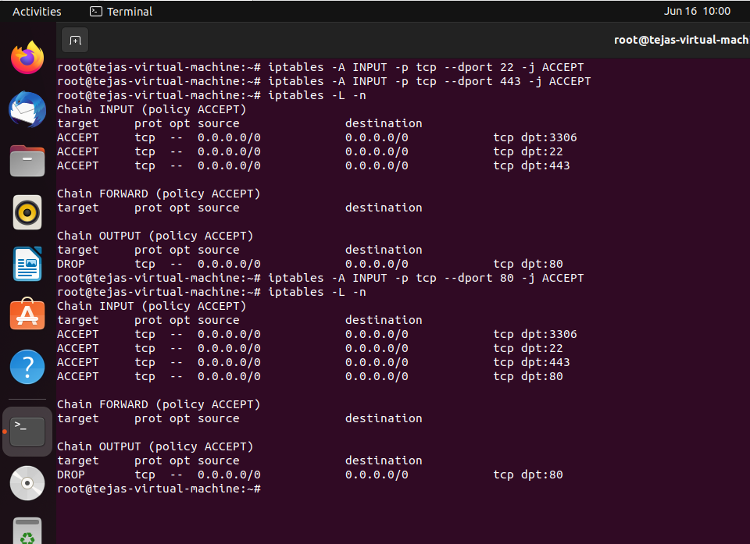

1. Block Facebook on Iptable firewall

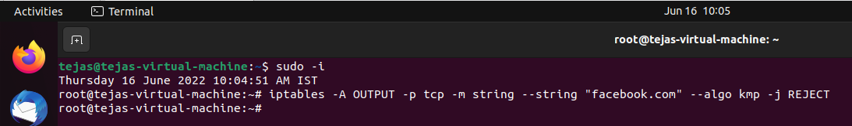

13. Get Tasks, Threads, Running Processes, Load Average and Uptime using htop command.

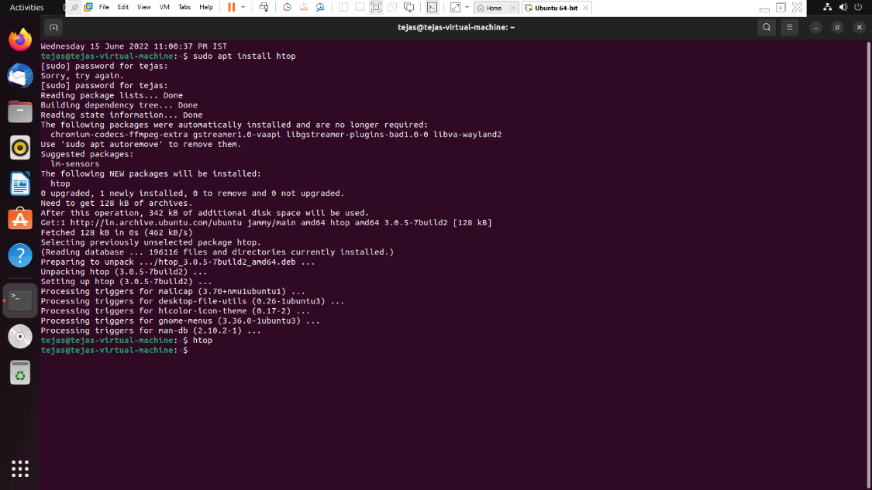

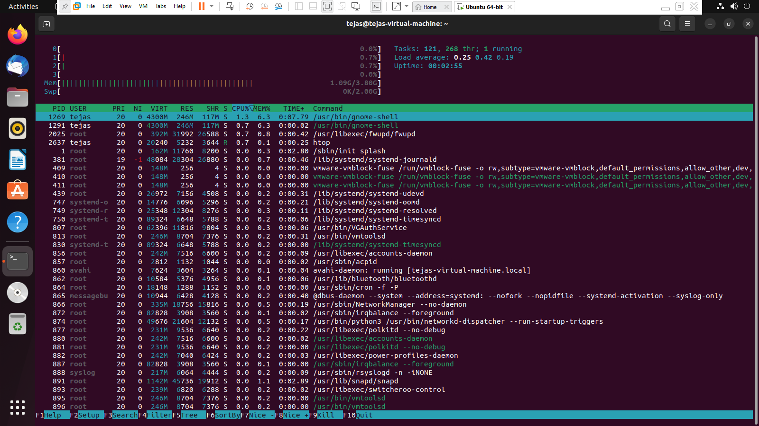

14. Using netstat command, perform the below operations

a. To display all the active list of listening port connections.

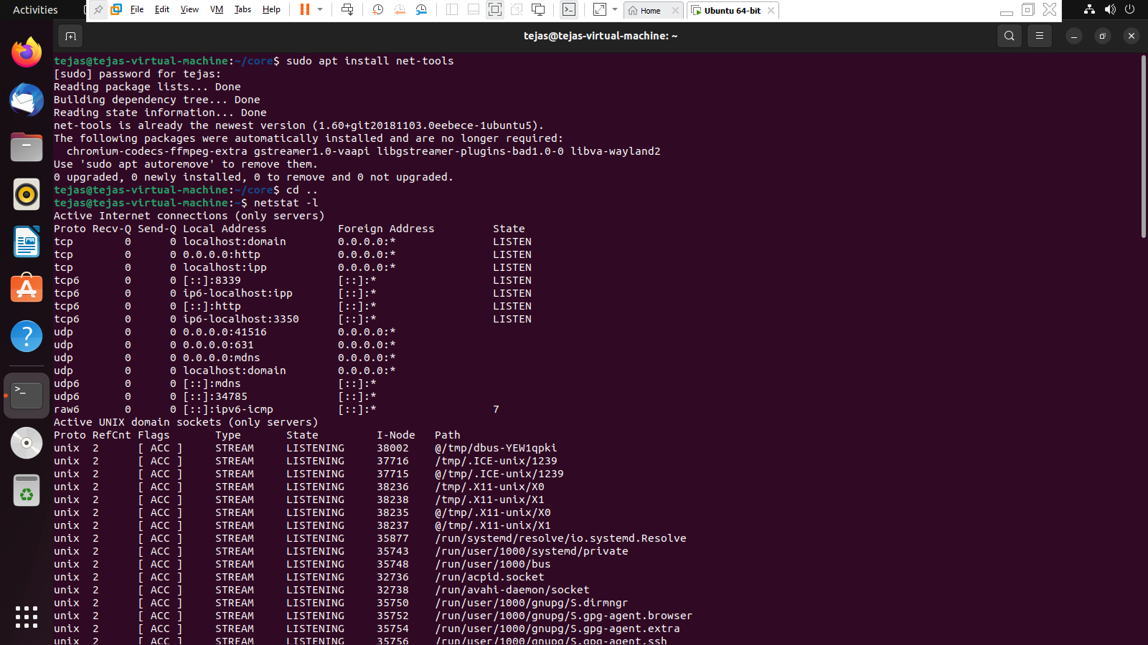

b. To display only the active listening TCP ports.

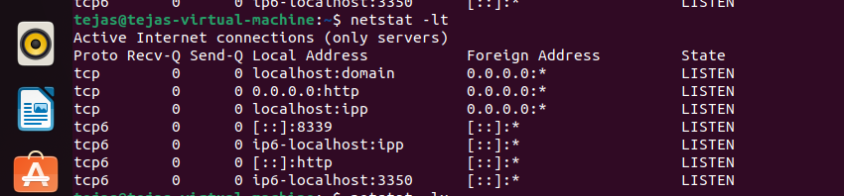

c. Netstat command in Linux will help to display all the active UNIX port connections.  
 